Skills / compétences

* Animal care and ethology / Soin des animaux et éthologie (photo Afrique)

I acquired a lot of notions about ethology during my Master degree and strengthened that knowledge with a specific training in animal care and management, during which I have learnt about animal classification, behaviour, biology, habitat, needs, diet, care, specific diseases etc. I studied many types of animals including primates, carnivores, sea mammals, birds and reptiles, and put into practice what I learnt during two internships and a volunteering.

One internship took place at the seal clinic of the Association for the Conservation of Sea Mammals and Birds of Brittany where I took in charge several tasks from first care of seals, measuring temperature, cleaning wounds, feeding, weighing, health monitoring, preparing the space, assisting in euthanasia and autopsy.

During my second internship, at a sanctuary in Zimbabwe, I had the chance to care for a great diversity of animals: birds, parrots, tortoises, domestic animals, bushbabies, duikers, lions, vervet monkeys etc. My missions were also varied: monitoring, wound care, vaccination for dogs, feeding, environmental enrichment, releasing, socialization, vet observations etc.

Finally, I volunteered for a local association who takes in charge wild mammals and birds and release them once they are ready to go back to nature. This experience allowed me to learn even more about other animal care, behaviour and rehabilitation process like squirrels, swans, pigeons hedgehogs etc.

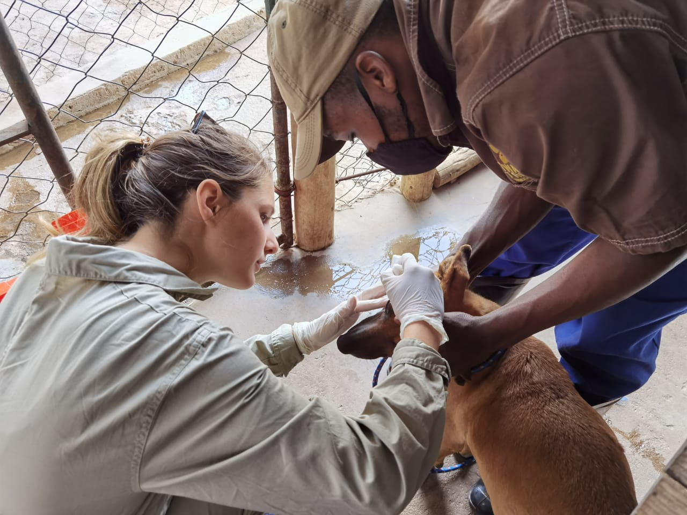

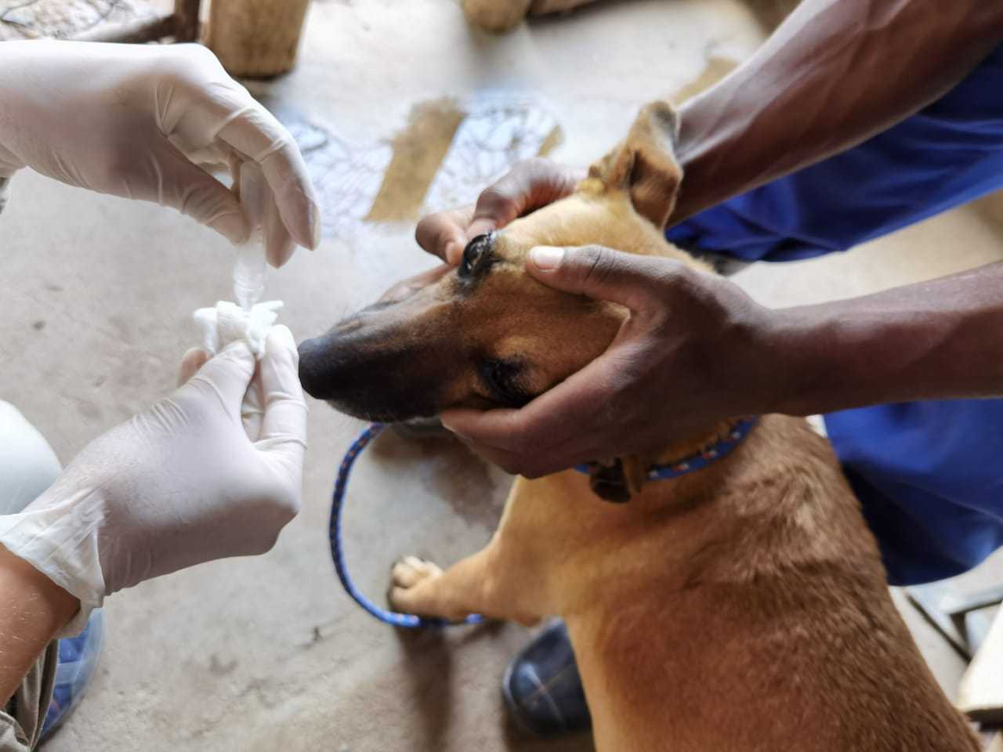

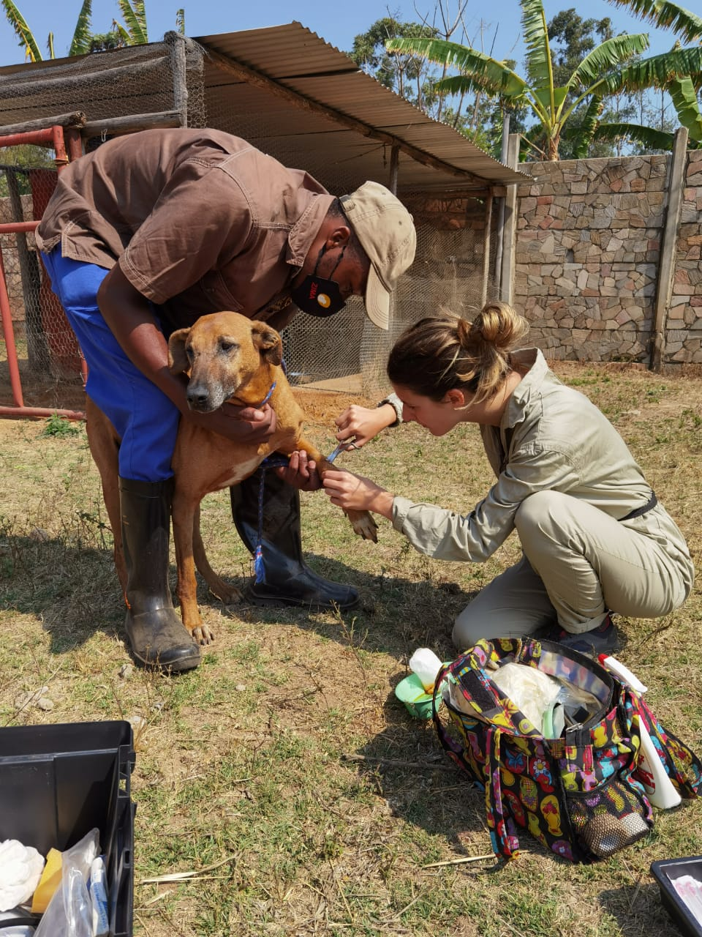

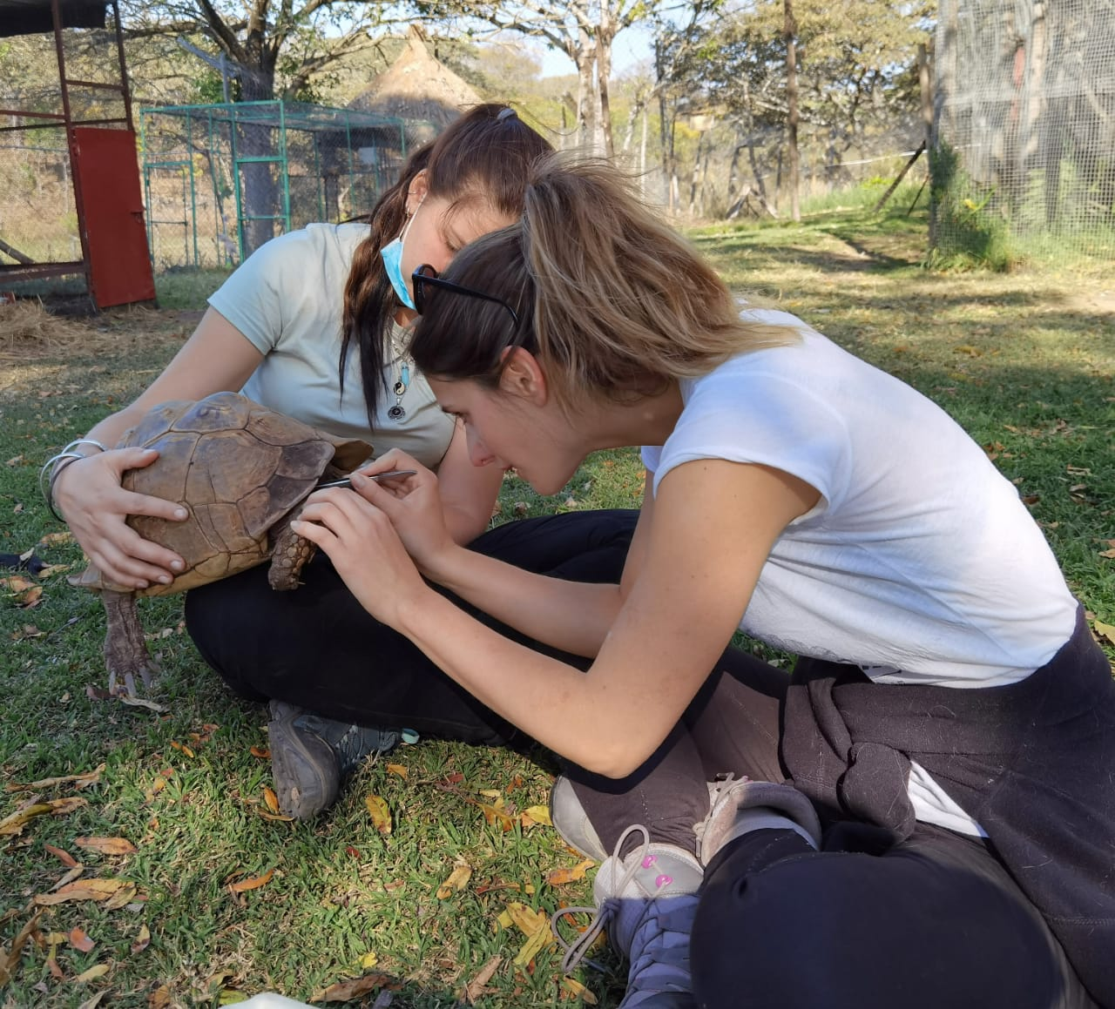

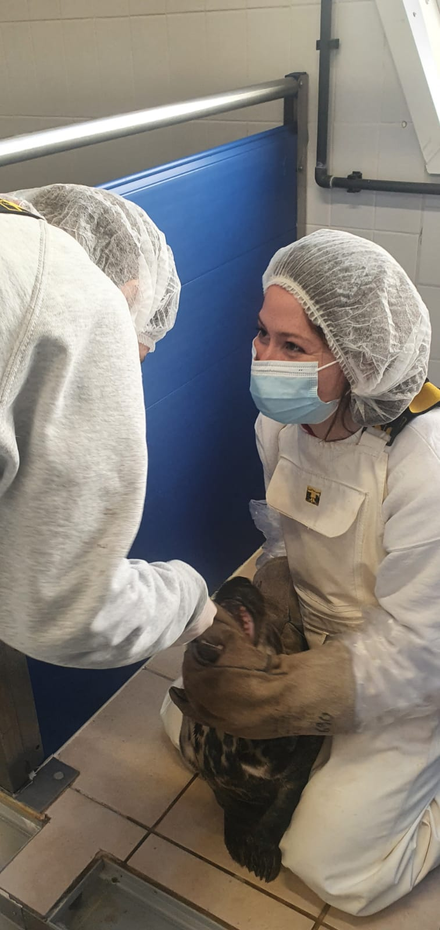

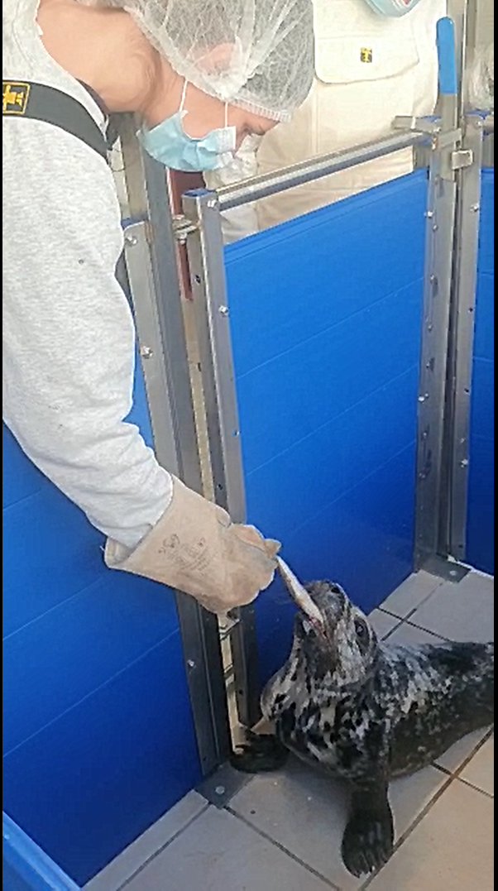

* Animal ethics and welfare / Ethique et bien-être de l’animal

My master degree permitted me to discover a fascinating subject that is animal ethics and welfare through interdisciplinary subjects such as philosophy, law, ethology, environmental management etc. I am specialized in animal ethics and I still read a lot about these subjects to deepen my understanding and knowledge. I am daily keeping up with the matter and I’m very concerned with any advances in animal welfare and protection.

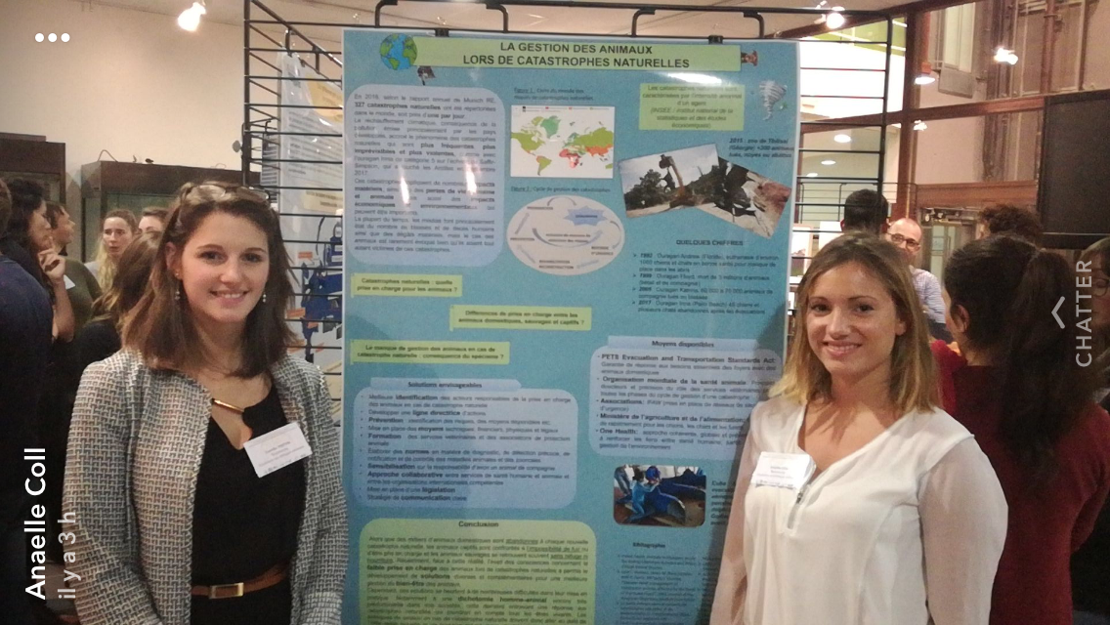

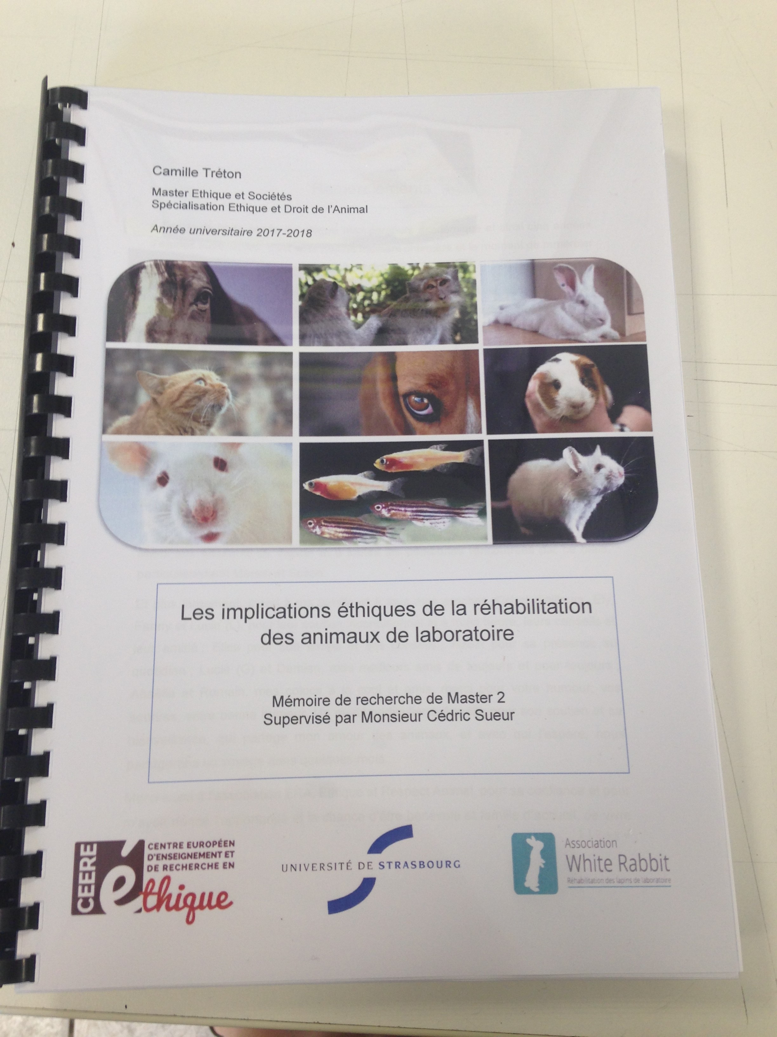

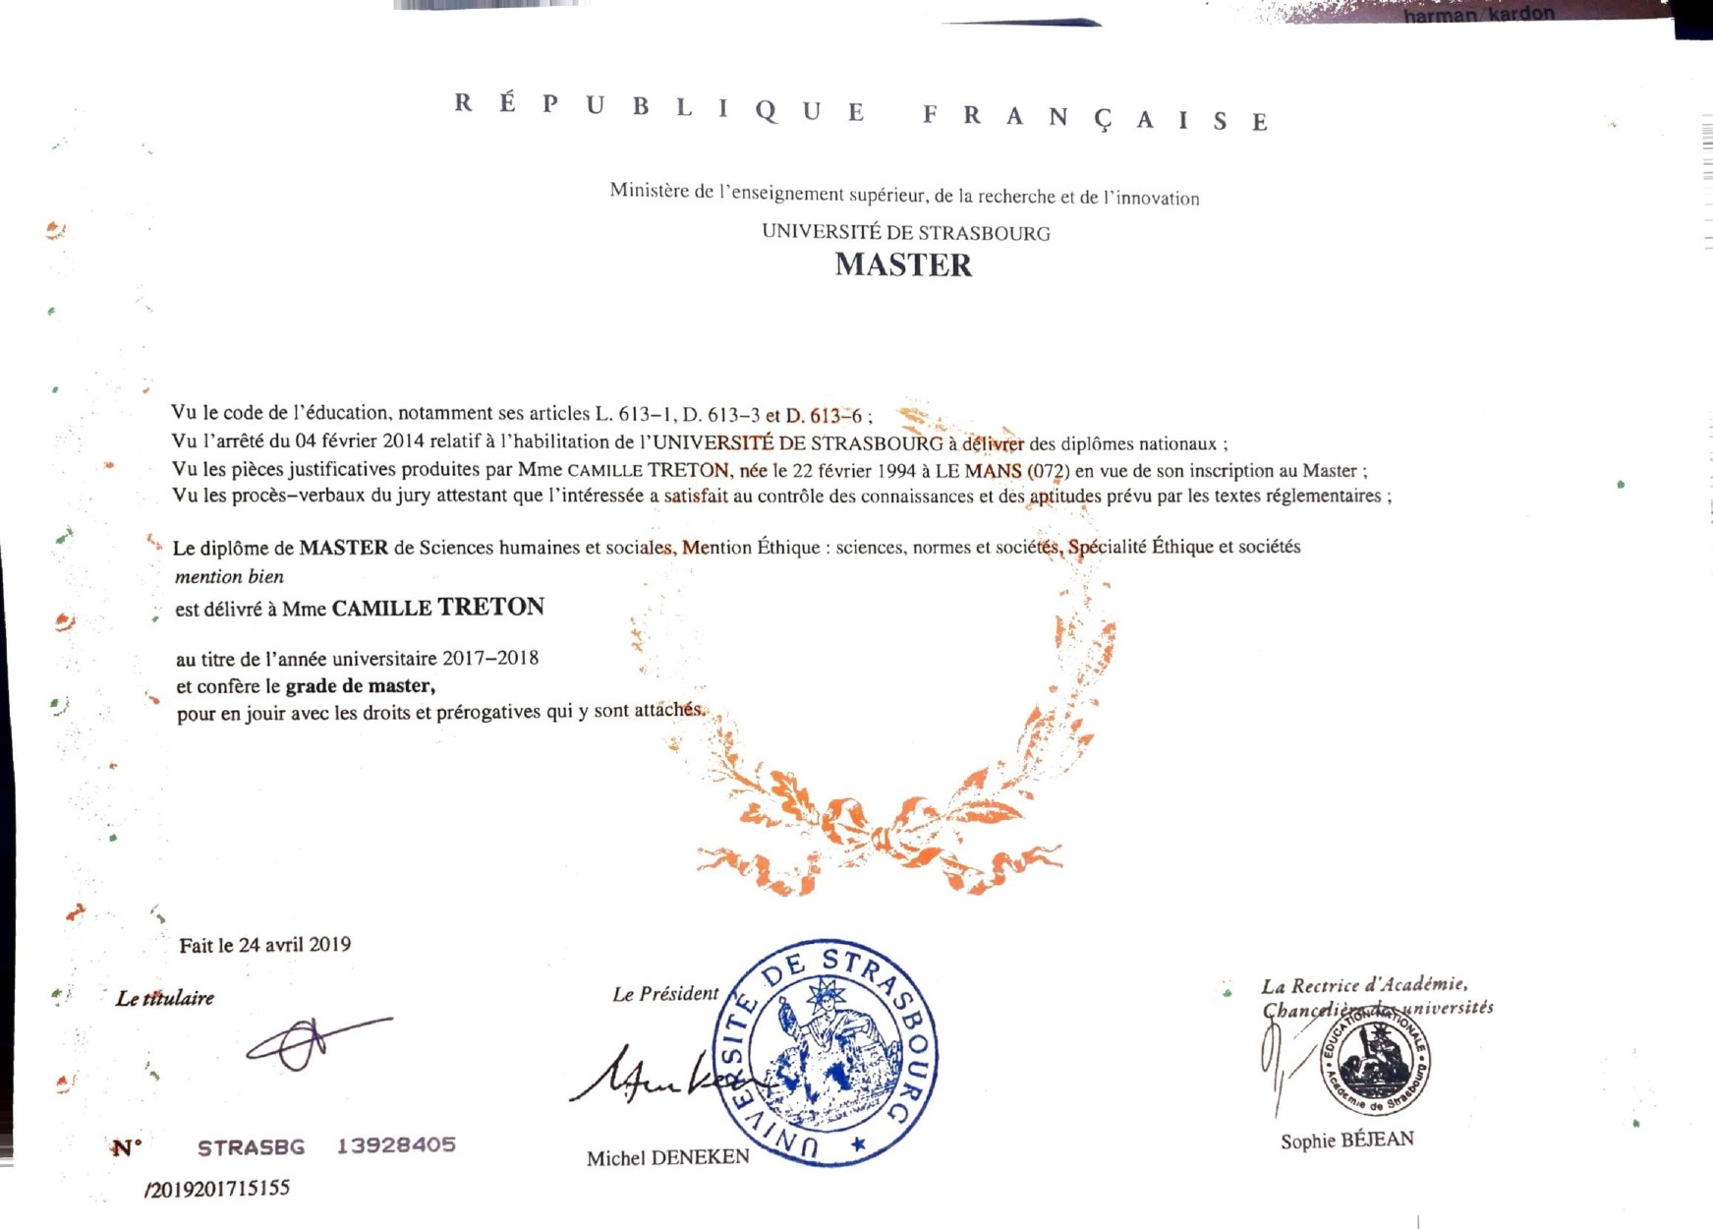

* Animal conservation and habitat management / Conservation des espèces et gestion des habitats.

Animal conservation is really the passion of my life. I am fascinated by the wild fauna that inhabits our planet and about ways to protect them from the numerous threats that they are subjected to currently. Discovering this domain of expertise through several trainings changed my life and gave me more motivation than ever to engage in preserving animals.

These trainings were dispensed by diverse organisms including the International Union for Conservation of Nature, Wildlife Act in Africa and Wildteam in the UK. I gained a lot of knowledge and skills such as tracking and monitoring animals, wildlife behaviour, camera trapping, wildlife crime and illegal trade, international and local threats, protected areas management, capture and relocation, habitat management, legal frame, the Red List managing and community conservation.

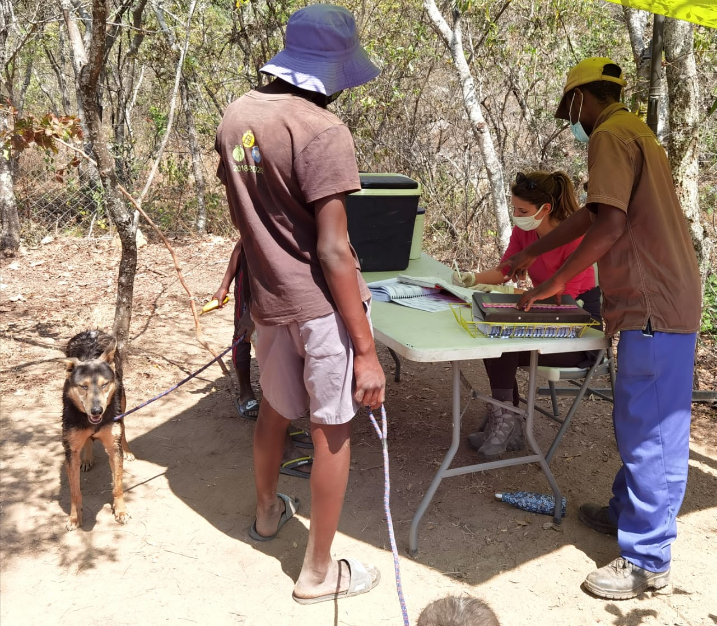

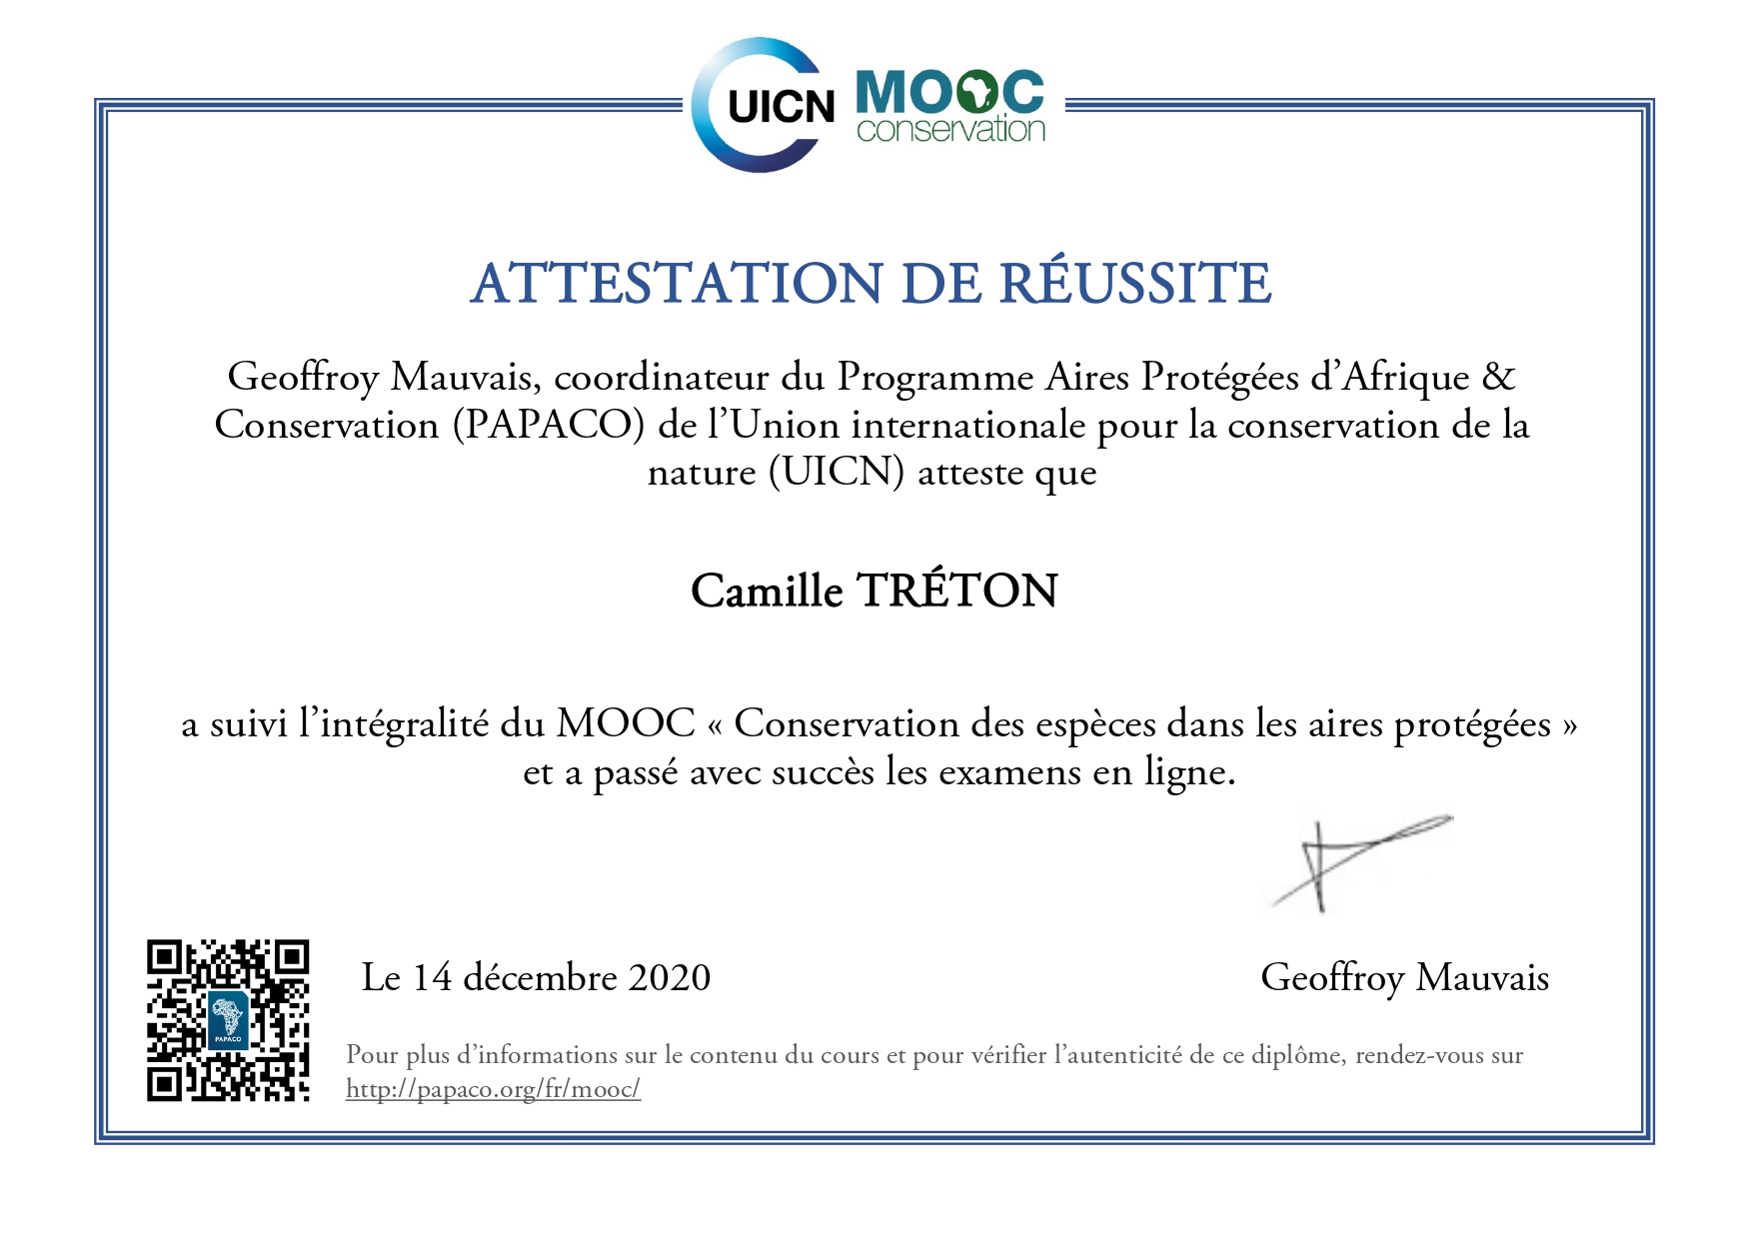

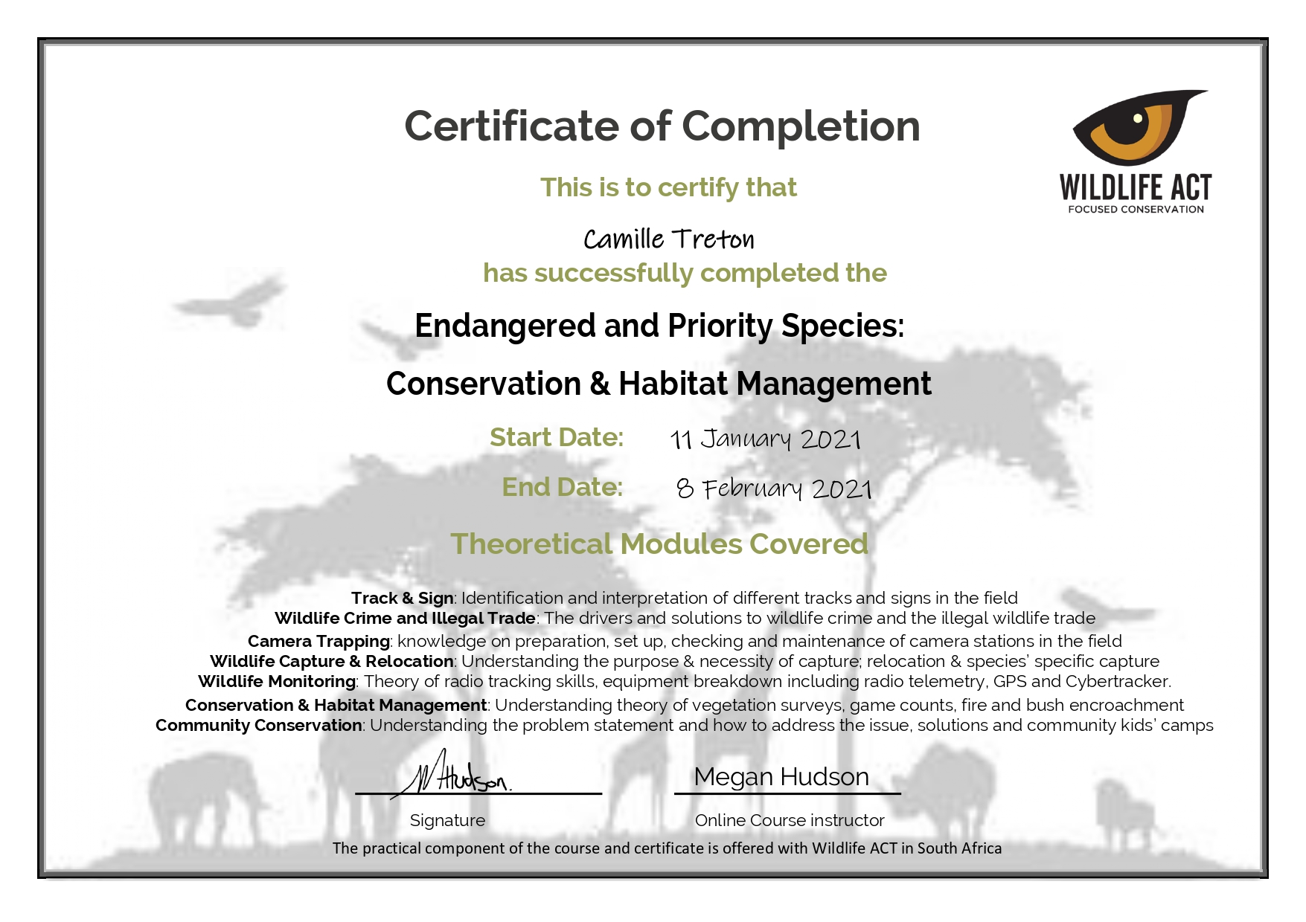

* Project management for wildlife conservation and humanitarian

After a training in project management for humanitarian programs, I wanted to specialize in project management for wildlife conservation. I had the occasion of doing so with an organism called Wildteam UK that delivered me three different trainings in **Project management**, **Strategy development** for wildlife conservation and **Grant writing** applying to conservation projects. I have acquired knowledge and skills in this area of expertise including situation analysis, assessing risks, implementing and monitoring the project, dispensing roles to the team, engaging stakeholders, defining the threats and the impact, planning the work, selecting and preparing a grant, evaluating the impact and administrative processes.

I now have the opportunity to apply these skills daily by assisting an NGO called Wildlife Angel in the development and management of their projects, and by looking for funds for these projects.

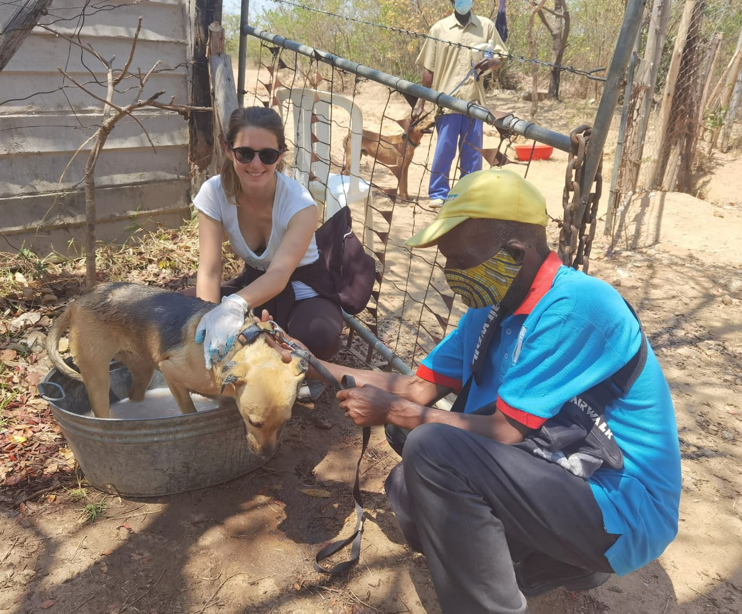

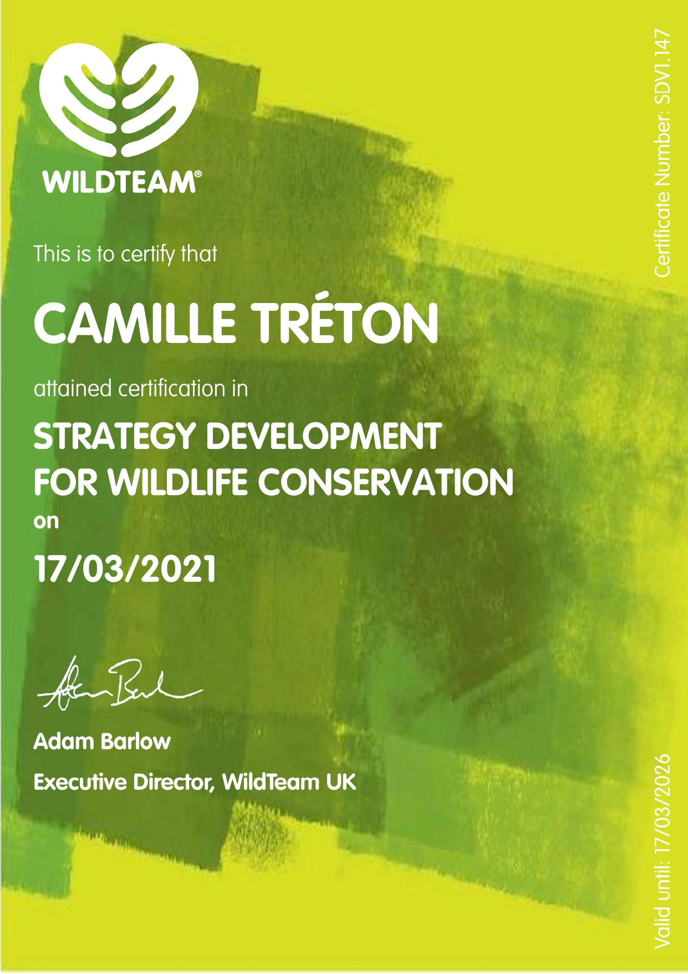

* English language

I studied English language, civilization and literature for three years and graduated a bachelor degree in the field. I love learning new things, and learning to talk another language and being able to communicate with so many people from different cultures and part of the world is rewarding and essential for me. Moreover, I absolutely loved my literature and civilization classes. Understanding the world, history of different cultures, but also the power of writing and reading, literacy using to spread messages... was what I preferred during these three years. I had the chance to apply my learning on a semester abroad in Sheffield, England. It was definitely one of the best experiences of my life: enjoying new ways of teaching and learning, living in a dynamic and multicultural city, meeting so many different people, travelling in England, discovering places and ways of living. All made it so special and unforgettable.

Now, as I don’t practice daily, especially my oral skills, my level decreased a little. But I try to keep it up by reading in English, taking training in English and keeping in touch with my friends and network who speaks English.

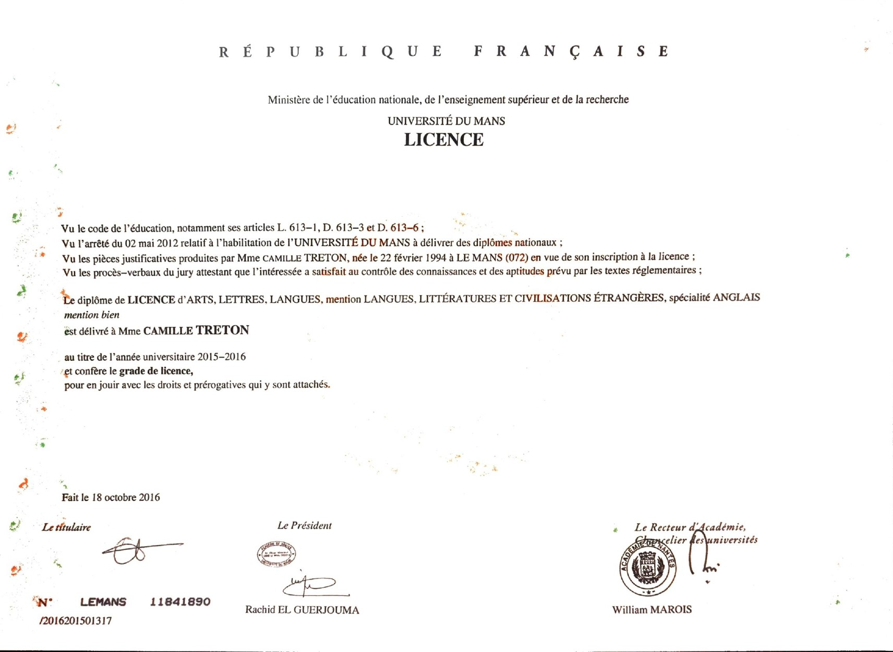



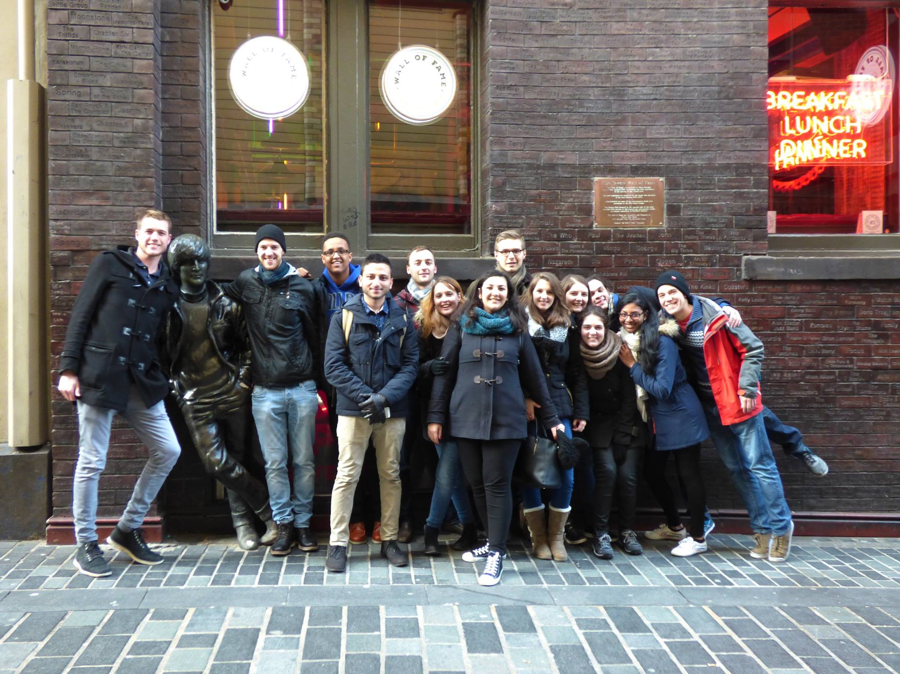

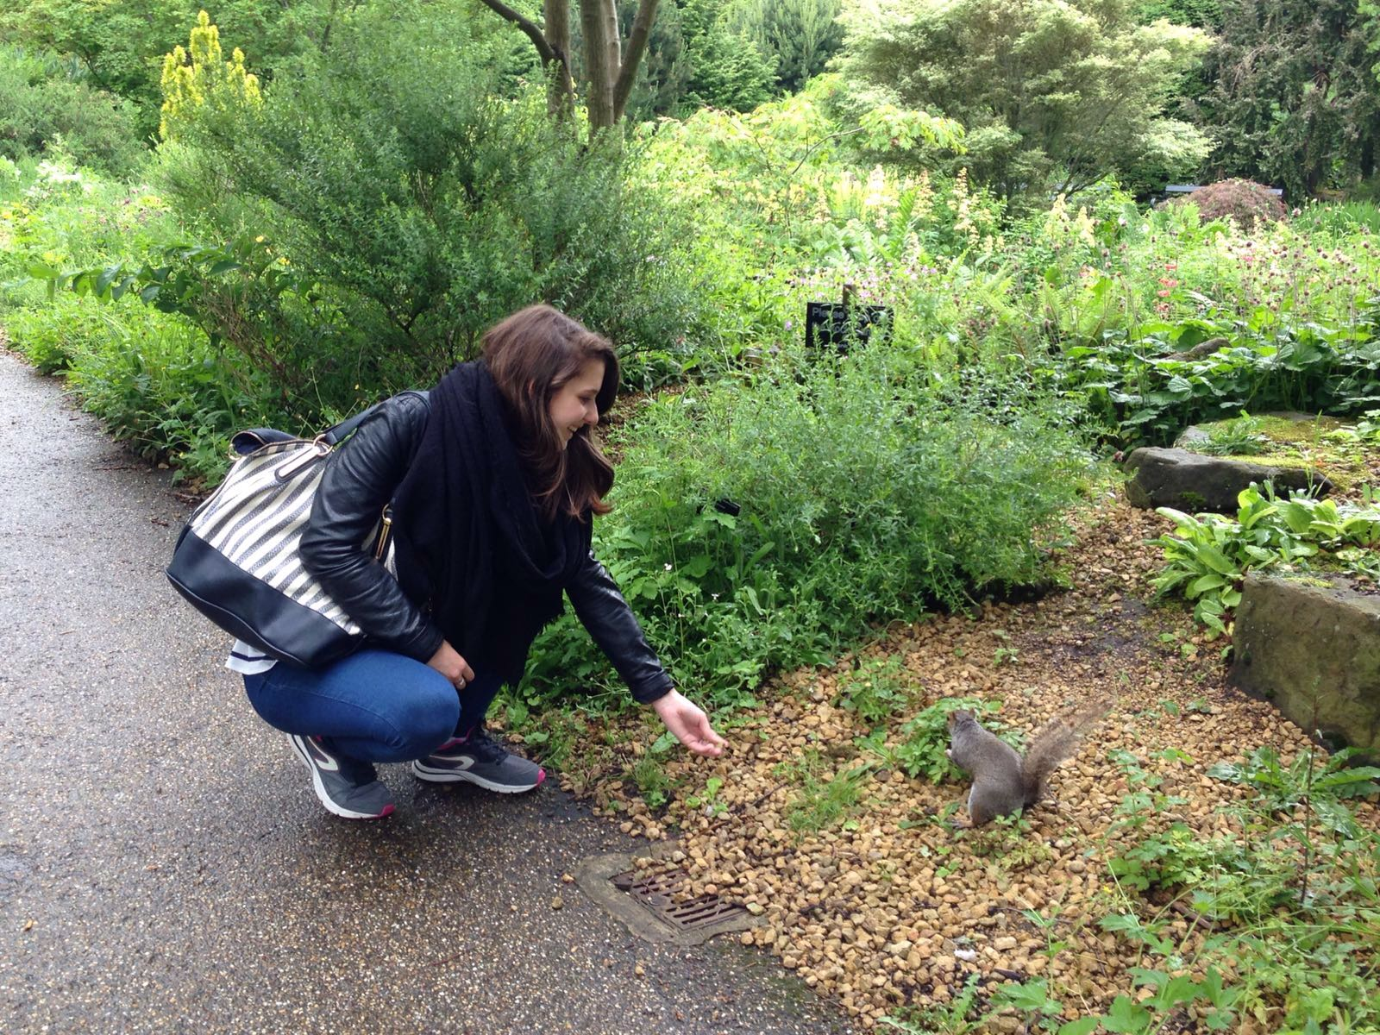

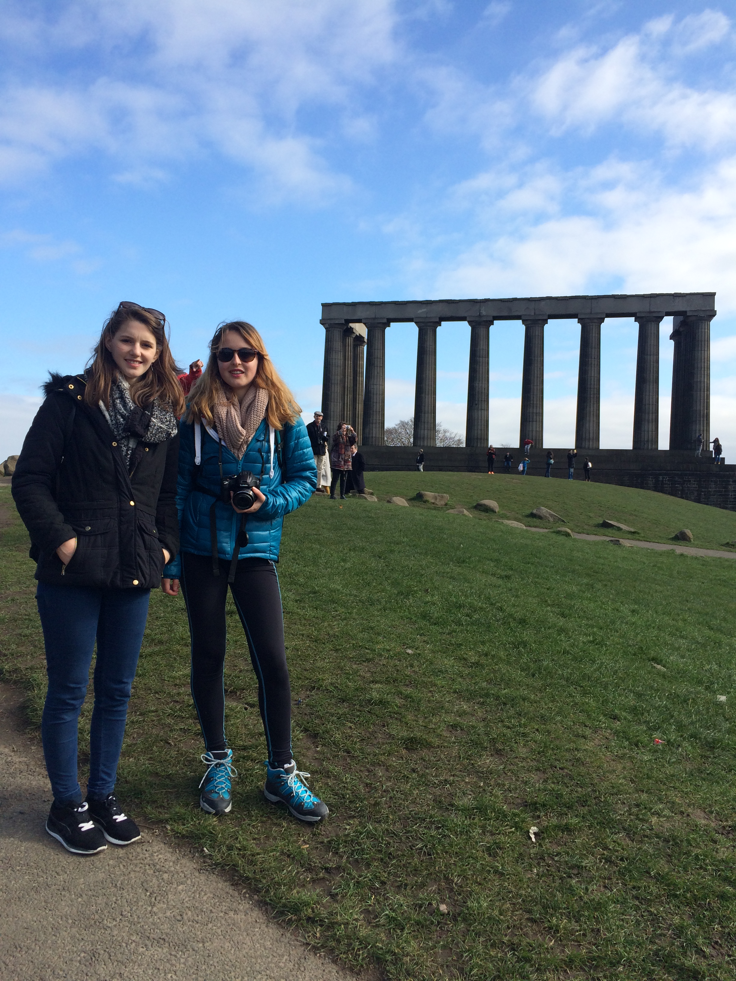

Projects / projets :

* Living a dream in Zimbabwe / Le rêve d’une vie au Zimbabwe (photos)

I have always wanted to travel the world to discover the magnificence of our planet biodiversity. After several aborted projects because of personal and worldwide obstacles, I finally have the opportunity to discover a small part of the African continent.

August 2021: I leave for Zimbabwe, next to Harare precisely. I had the chance to experience volunteering at Twala Trust Animal Sanctuary for a month learning so much about animal care, African wild and domestic fauna, conservation, legal frame, rehabilitation, illegal wild and pet trade in the country, community support and engagement, running such an organization...

The diversity of fauna in the sanctuary was astounding and the peacefulness and beauty of the site made it a really special place.

I had the great chance to visit many places among which the incredible Victoria Falls National Park and surroundings, Wild is life sanctuary, cultural sites and the city of Harare. During my trip, I got to go on safari at the Stanley and Livingstone private reserve where I saw many animals such as several black rhinos in their natural environment. I also experienced a cruise on the Zambezi River where I was lucky enough to observe elephants crossing over. All these experiences amazed me, moved me deeply and strengthened even more my desire to dedicate my work and life to animals' protection and urged me in doing so.

It was the first time for me in Africa and the first time seeing African fauna where it belongs, in its natural habitat. I think I could not have dreamt of a better first experience. I cannot wait to go back to this continent I definitely fell in love with.

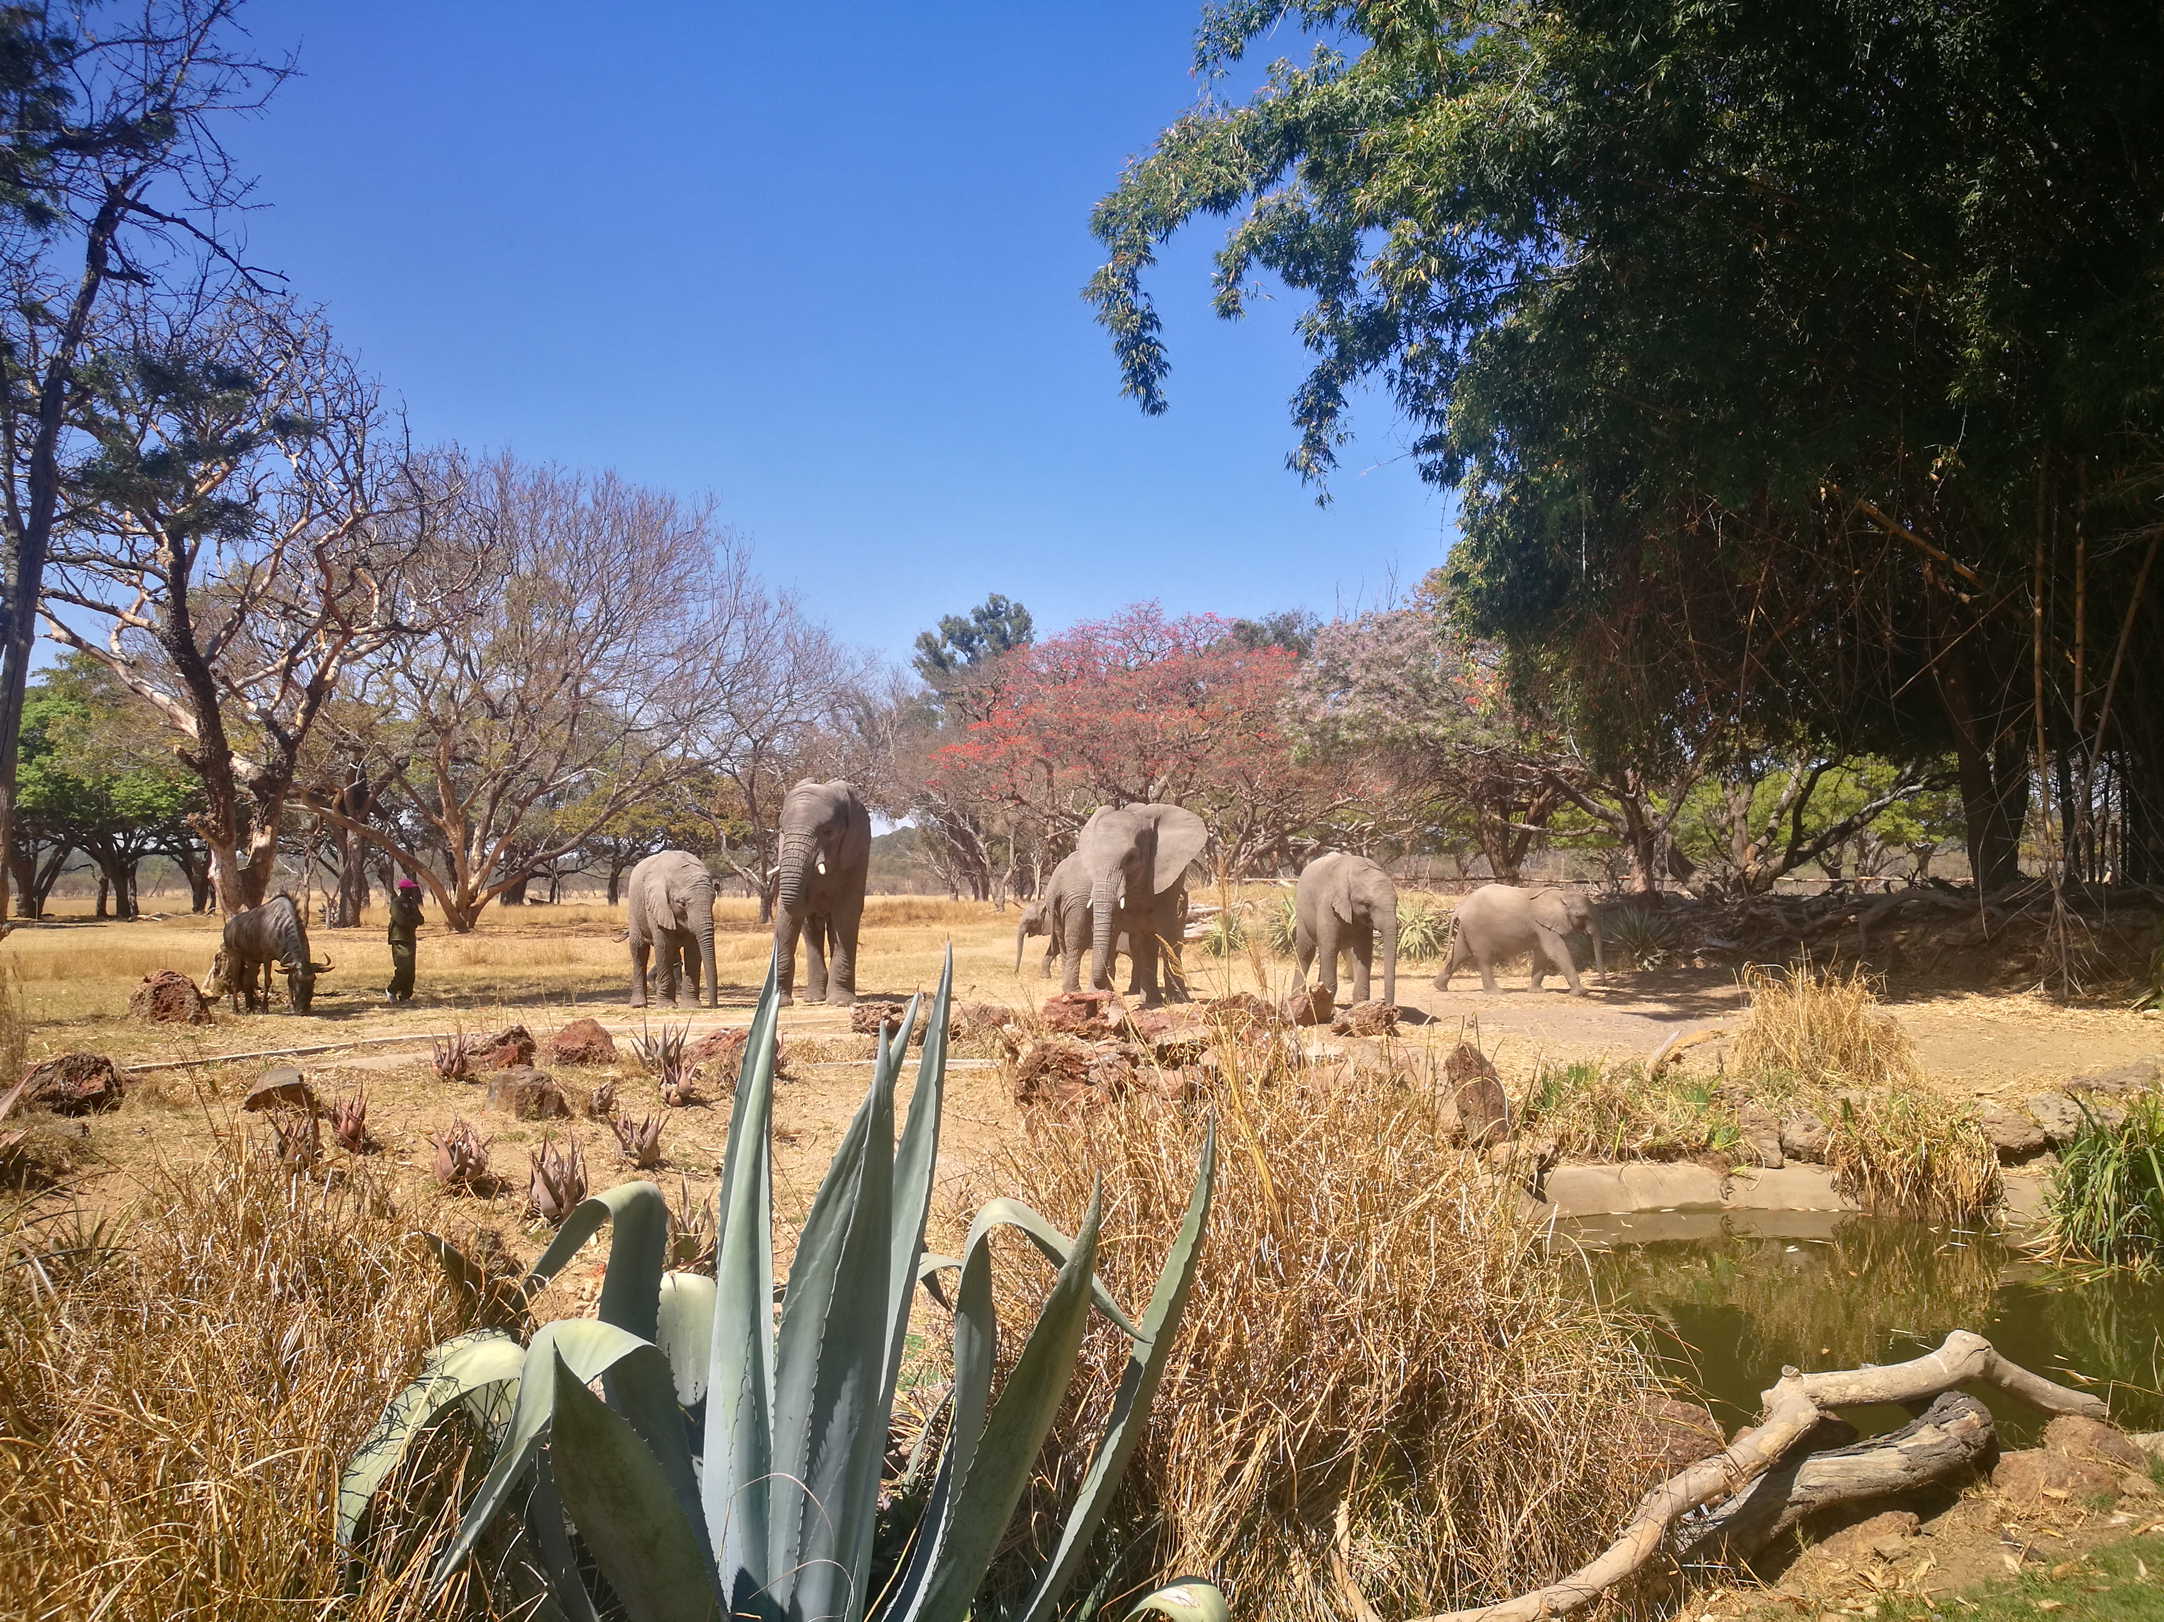

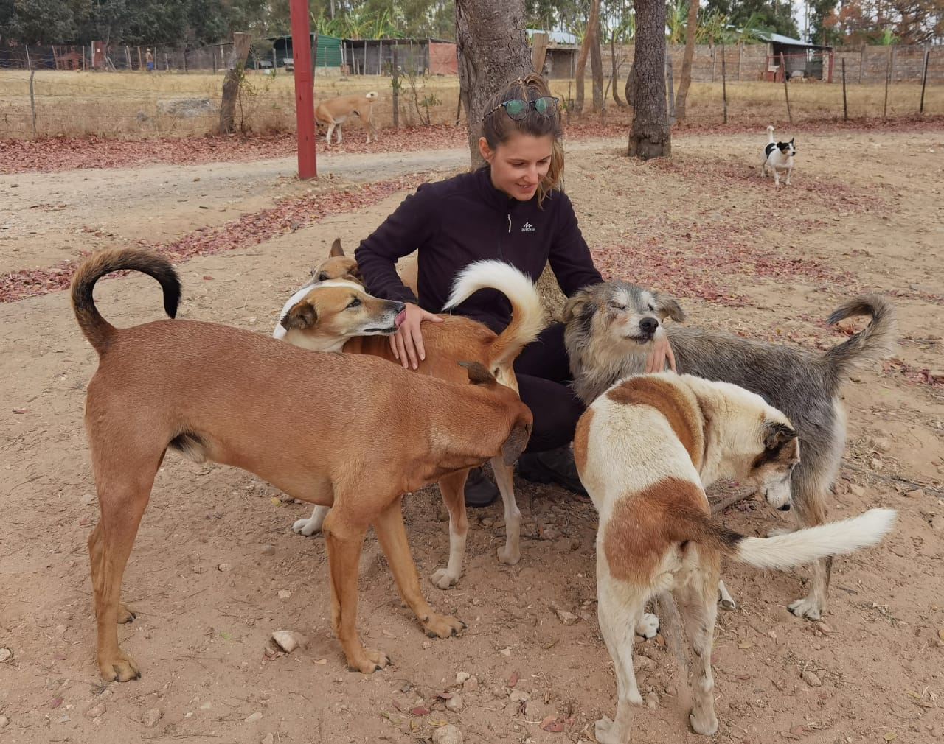

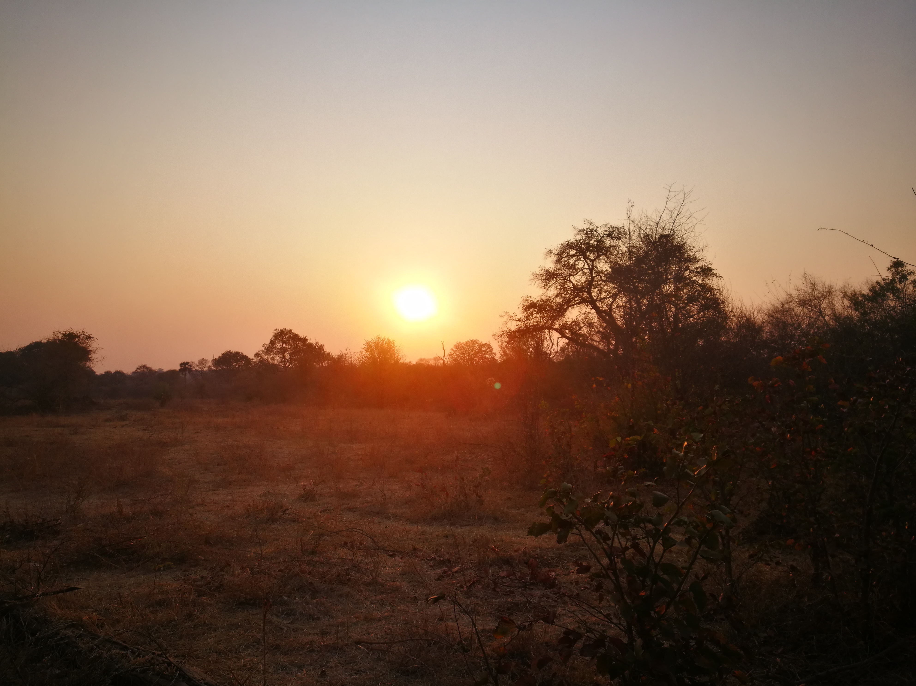

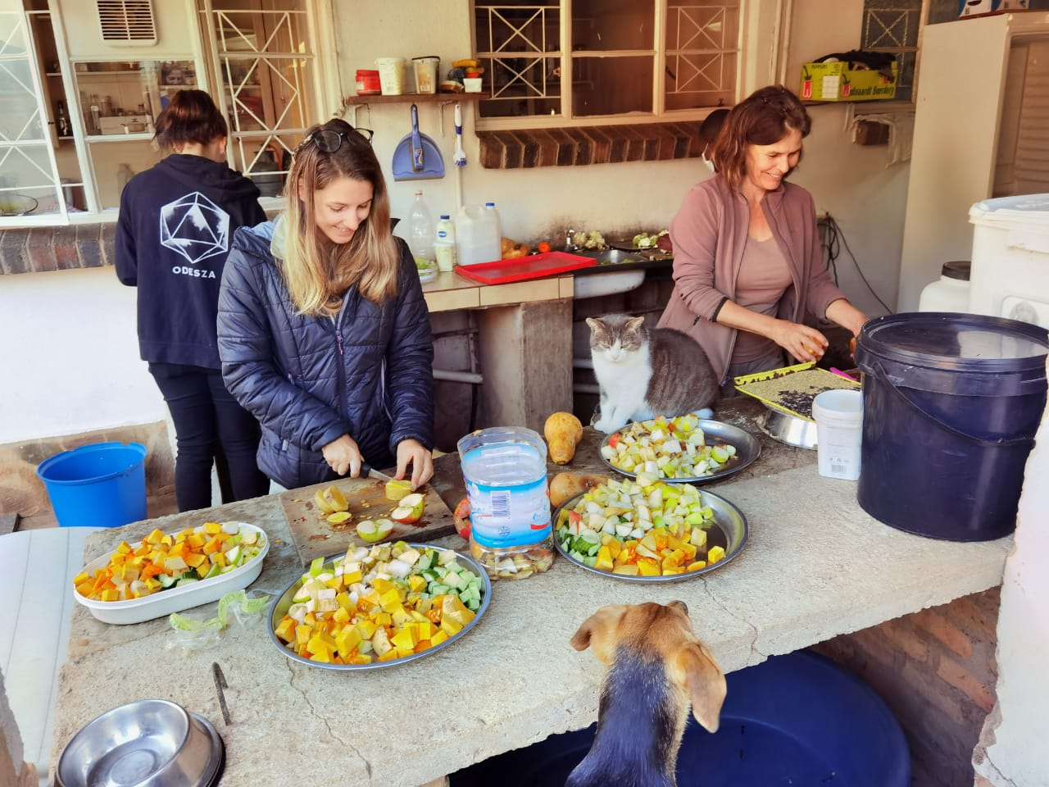

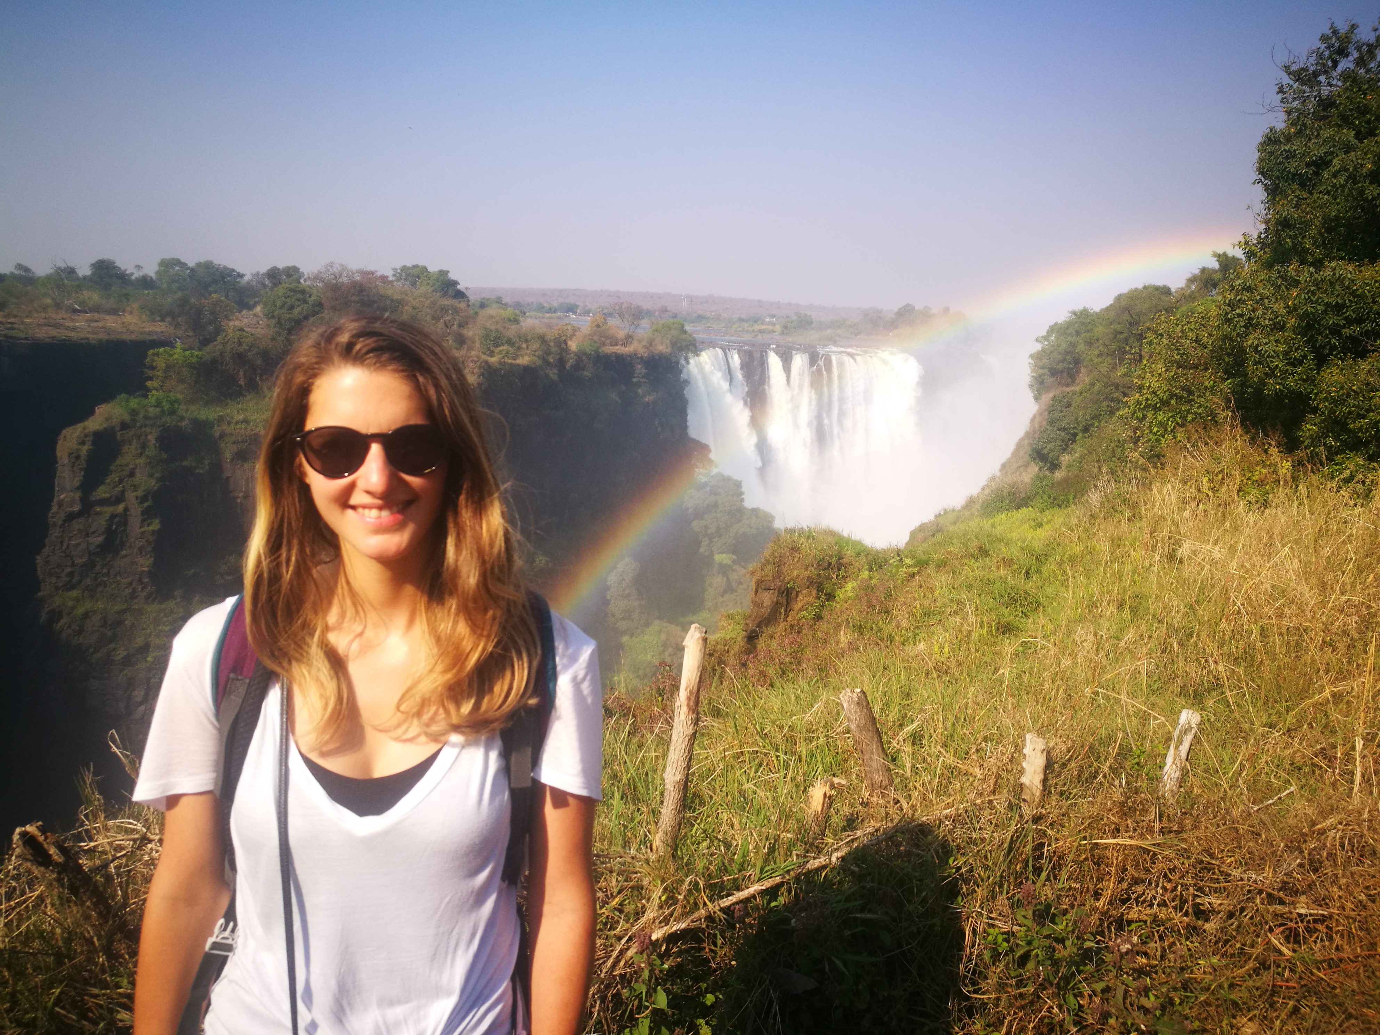

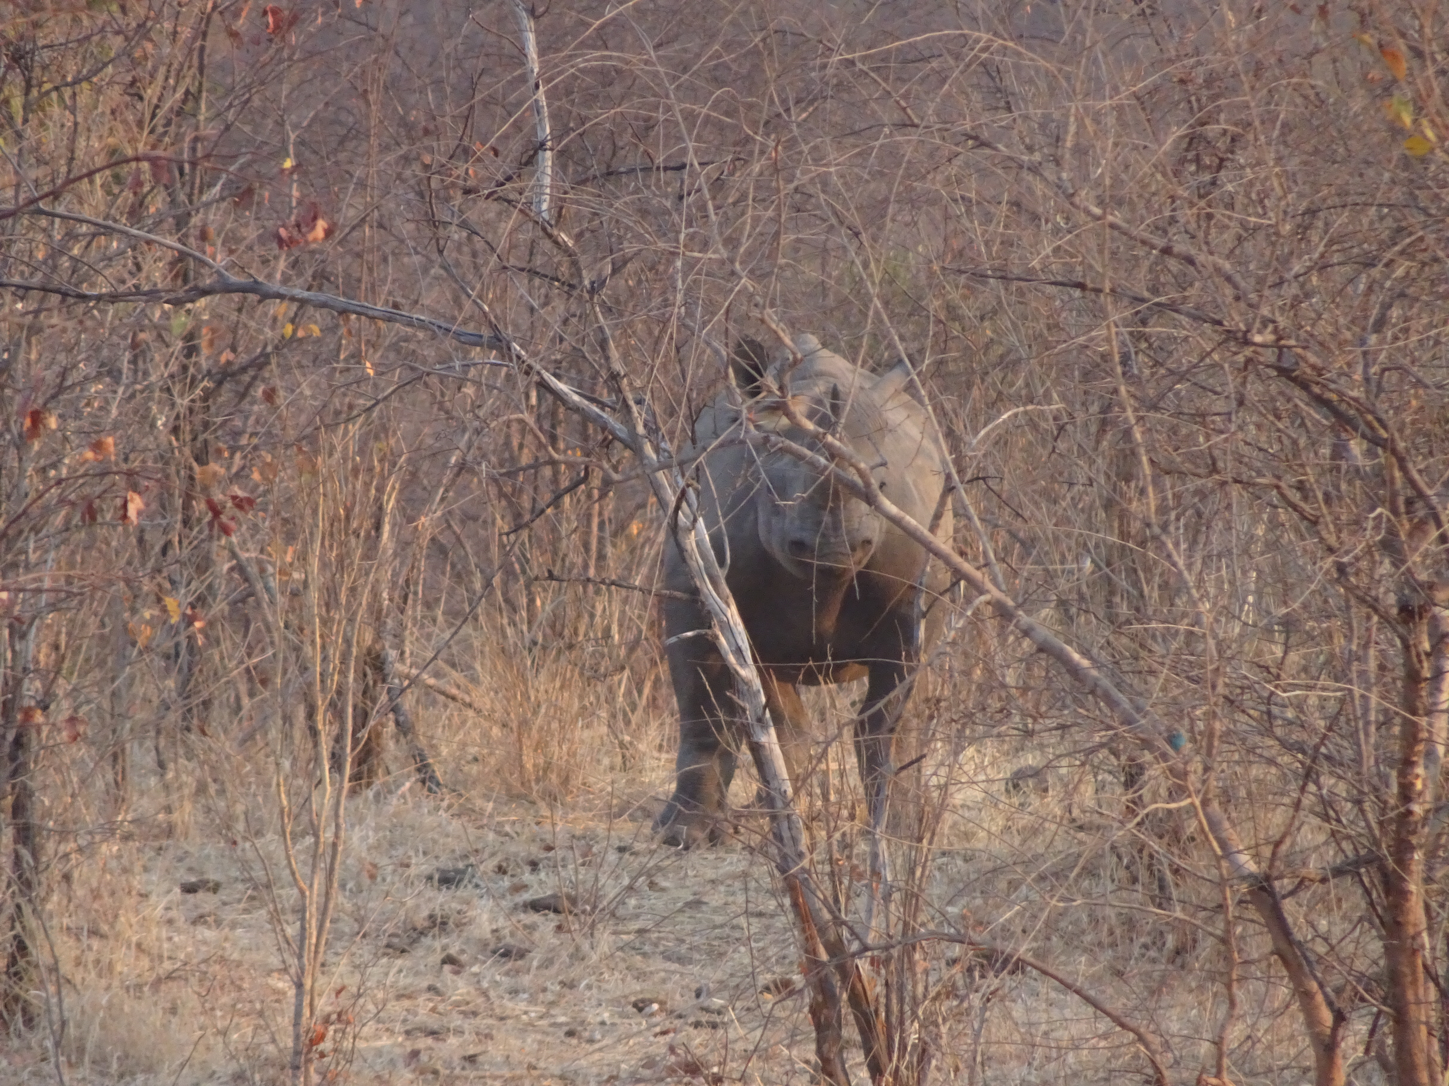

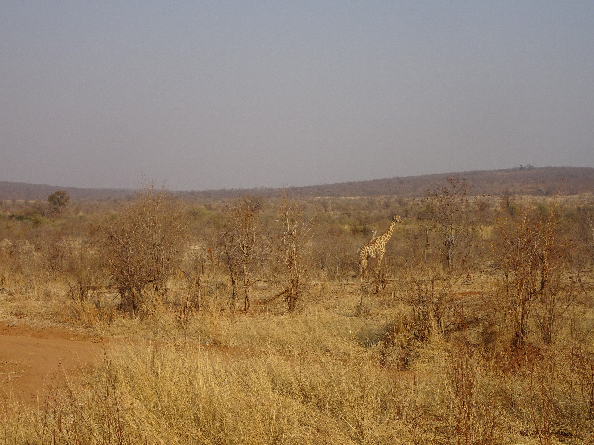

* Volunteering for Wildlife Angel / bénévole pour Wildlife Angel (photo logo, photo autre?)

Wildlife Angel is a French NGO founded in 2015 by Sergio Lopez. It is a field organisation specialized in the protection and conservation of African wildlife through anti-poaching response and operational support to rangers. They not only train rangers in Africa through specific and adaptative skills, but also provide necessary equipment and engage communities along the project.

I daily and actively help their actions by executing different missions from monitoring latest news in conservation, to research for funding, assisting in project management, setting up training plans, and working on solutions for tackling human and wildlife conflict in the regions of intervention.

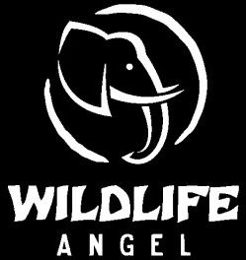

* Being a foster family / Etre famille d’accueil (photos chats)

Since 2016, I have been volunteering for a cat's shelter in Strasbourg. I not only help with weekly cleaning and feeding the cats at the shelter, but I’m also and mainly a foster family. I have welcomed many cats from babies, sick and old cats, and numerous cats who were afraid or traumatised and needed time, love and socialization to find their forever homes.

This experience that I currently carry on was self-evident for me who has always lived with animals. Not only it taught me knowledge and skills about cat diseases, the process of socialization, and medical care, but also qualities and interpersonal skills such as patience, tolerance, calmness, responsibility, being able to select a good family and to make some hard decisions sometimes for cats whose condition is no longer viable.

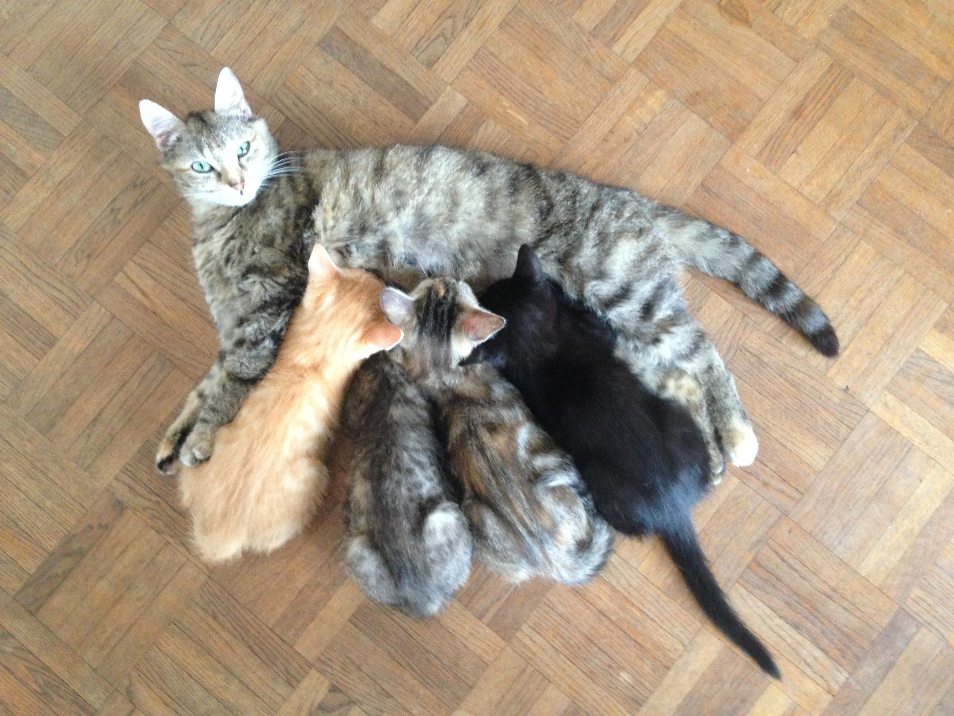

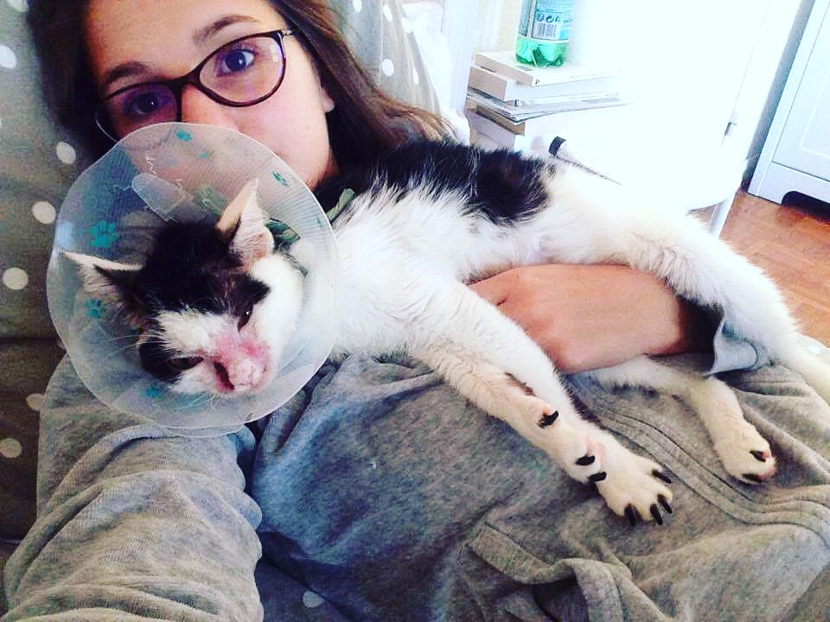

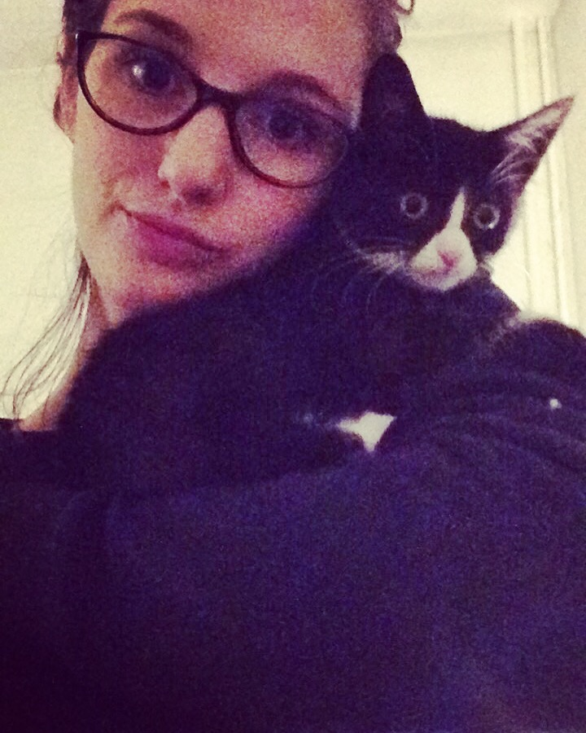

About me / à propos de moi :

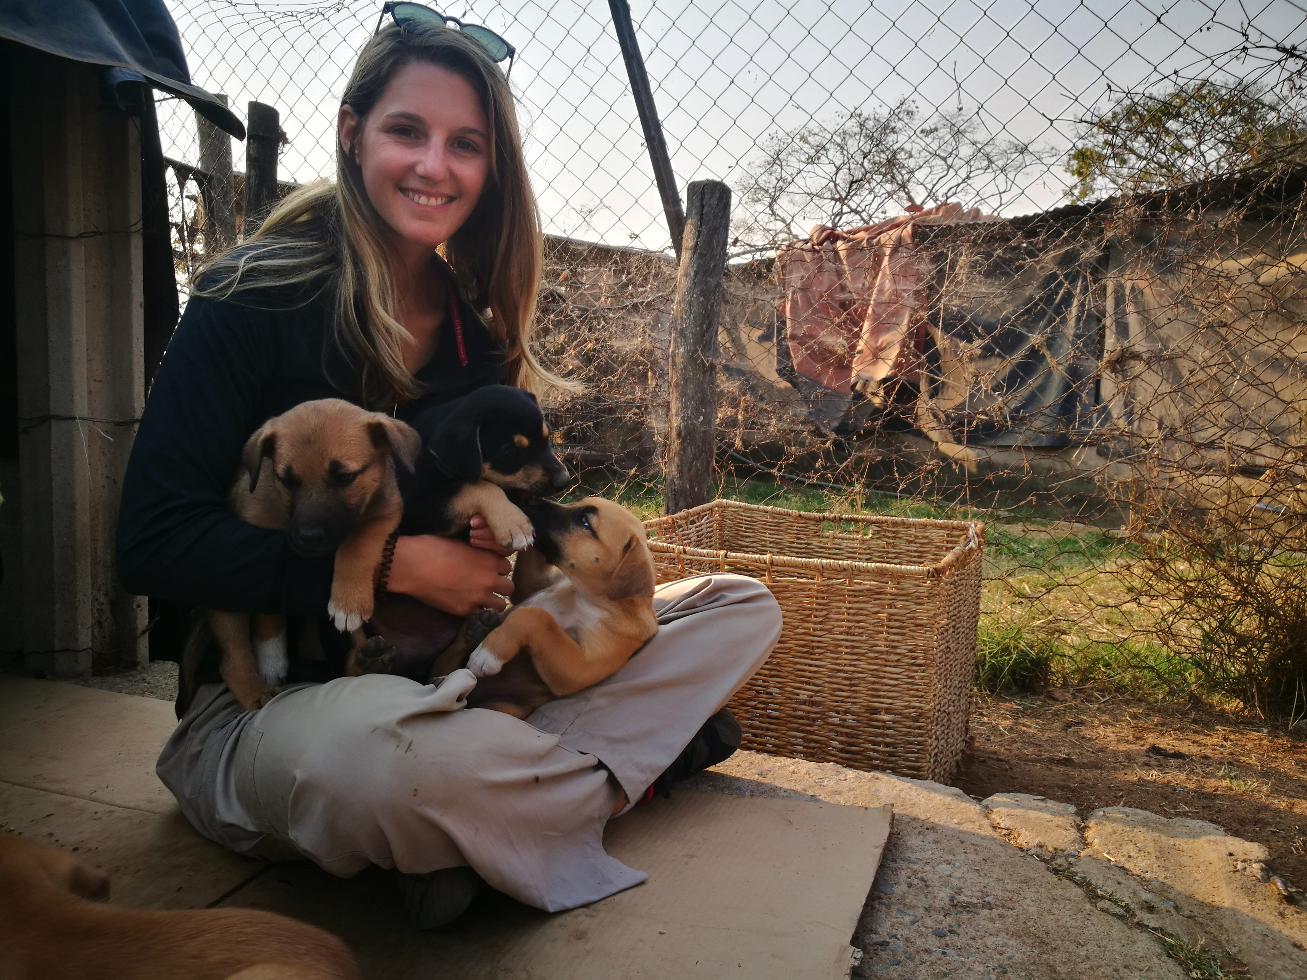

After a Master degree in ethics, welfare and animal law from the University of Strasbourg and several disappointing professional experiences, I decided to keep learning and I train myself in the field of species conservation: project management, habitat management, animal care, human and wildlife conflict management, strategy development for conservation etc.

At the same time, I had the opportunity to take part in different field experiences through internships and volunteering for different associations including local wildlife rehabilitation centre, seal rehabilitation centre in Brittany and more recently by leaving to the continent of my dreams to discover African fauna in a rehabilitation sanctuary for wild and domestic animals in Zimbabwe.

These experiences gave me the chance to discover a great diversity of domestic and wild animals and to provide various missions from animal care, rehabilitation, release, monitoring etc.

Since I was little, I have been very sensitive to the welfare of others. This awareness undoubtedly shapes the basis of my behaviour and beliefs, and also stands as the source of my wishes in my professional and personal projects.

Today, my daily life is split between working at a public library – allowing me to live close to another of my passions: books – and volunteering for Wildlife Angel, an NGO who directly takes action on the African field, close to wildlife and rangers, in charge of protecting animals.

Thus, I carry on my path and hope to get the job which will permit me to combine my deep desire of protecting nature, and the skills acquired along the way.

Contact :

[camille.treton@hotmail.fr](mailto:camille.treton@hotmail.fr)

06.11.37.58.80

<https://www.linkedin.com/in/camille-tr%C3%A9ton-96356b123/>

Après un Master en Ethique, bien être et droit de l’animal de l’Université de Strasbourg, suivi de quelques expériences décevantes dans le monde du travail, je décide de continuer à apprendre et enchaîne les formations dans le domaine de la conservation des espèces en particulier: gestion de projet, management des habitats, fonctionnement des aires protégées, soins des animaux, gestion des conflits hommes/animaux, développement stratégique pour la conservation etc. En parallèle, j’ai la chance de connaître plusieurs expériences de terrain à travers des stages et du bénévolat. Ainsi, j’ai pu mettre en pratique mes connaissances et compétences et en développer de nouvelles grâce à un volontariat à la Ligue de protection des oiseaux et mammifères d’Alsace, un stage à la clinique des phoques de l’ACMOM (Association pour la conservation des mammifères et oiseaux marins de Bretagne) et plus récemment en partant sur le continent de mes rêves à la découverte de la faune africaine dans un sanctuaire pour animaux domestiques et sauvages.

Depuis mon plus jeune âge, j'ai été sensibilisée au bien-être de tous, une sensibilisation à l'origine de ma conduite ainsi que de mes idées, et, sans aucun doute, à la base de mes désirs et projets professionnels et personnels.

Aujourd’hui, mon quotidien se partage entre un emploi à la médiathèque - me permettant d’être au plus proche d’une autre de mes passions : la lecture ; et les missions de bénévolat au sein de l’ONG Wildlife Angel. Celle-ci, fondée en 2015 par Sergio Lopez, est une organisation de terrain spécialisée dans la protection et la sauvegarde de la faune africaine, via la lutte anti-braconnage et le soutien opérationnel aux rangers. Je participe quotidiennement et activement à leurs actions en réalisant des missions polyvalentes allant de la veille de l’actualité, la recherche de financement, l’assistance à la gestion des projets, la mise en place des plans de formation, la réflexion autour de solutions pour atténuer les conflits hommes/animaux dans les régions d’intervention.

C’est ainsi que je continue ma route et espère trouver le métier qui me permettra d’allier mes désirs profonds de protection de la nature, et les compétences acquises en cours de chemin.